SISProject/**azure-pipelines.yml**

# ASP.NET Core (.NET Framework)

# Build and test ASP.NET Core projects targeting the full .NET Framework.

# Add steps that publish symbols, save build artifacts, and more:

# https://docs.microsoft.com/azure/devops/pipelines/languages/dotnet-core

trigger:

- master

pool:

  name: 'default'

  vmImage: 'H30007'

variables:

  solution: '**/*.sln'

  buildPlatform: 'Any CPU'

  buildConfiguration: 'Release'

steps:

- task: NuGetToolInstaller@1

- task: NuGetCommand@2

  inputs:

    restoreSolution: '$(solution)'

- task: SonarQubePrepare@4

  inputs:

    SonarQube: 'SonarDevOpsSIS'

    scannerMode: 'MSBuild'

    projectKey: 'SISProject'

    projectName: 'SISProject'

- task: VSBuild@1

  inputs:

    solution: '$(solution)'

    msbuildArgs: '/p:DeployOnBuild=true /p:WebPublishMethod=Package /p:PackageAsSingleFile=true /p:SkipInvalidConfigurations=true /p:DesktopBuildPackageLocation="$(build.artifactStagingDirectory)\WebApp.zip" /p:DeployIisAppPath="Default Web Site"'

    platform: '$(buildPlatform)'

    configuration: '$(buildConfiguration)'

- task: DotNetCoreCLI@2

  displayName: 'dotnet test'

  inputs:

    command: 'test'

    projects: '**/*Test.csproj'

    arguments: '/p:CollectCoverage=true /p:CoverletOutputFormat=cobertura /p:CoverletOutput=./MyCoverage/'

    publishTestResults: true

- task: PublishBuildArtifacts@1

  inputs:

    PathtoPublish: '$(Build.ArtifactStagingDirectory)'

    ArtifactName: 'SISDrop'

    publishLocation: 'Container'

- task: SonarQubeAnalyze@4

- task: SonarQubePublish@4

  inputs:

    pollingTimeoutSec: '300'

Release Pipeline

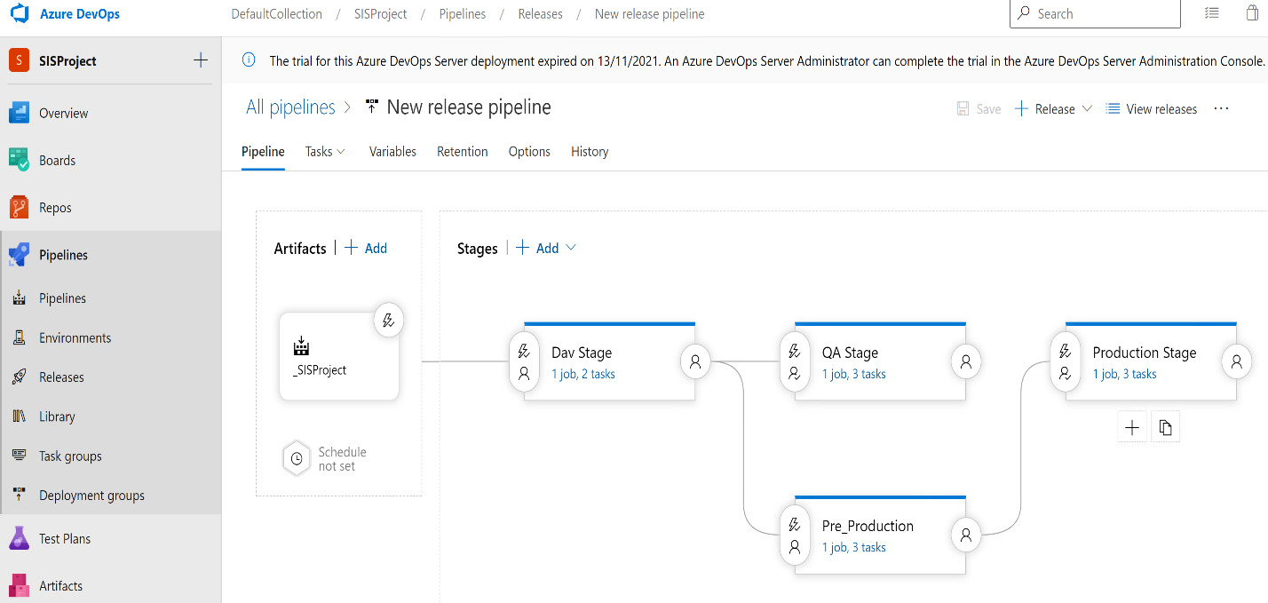

Artifact:

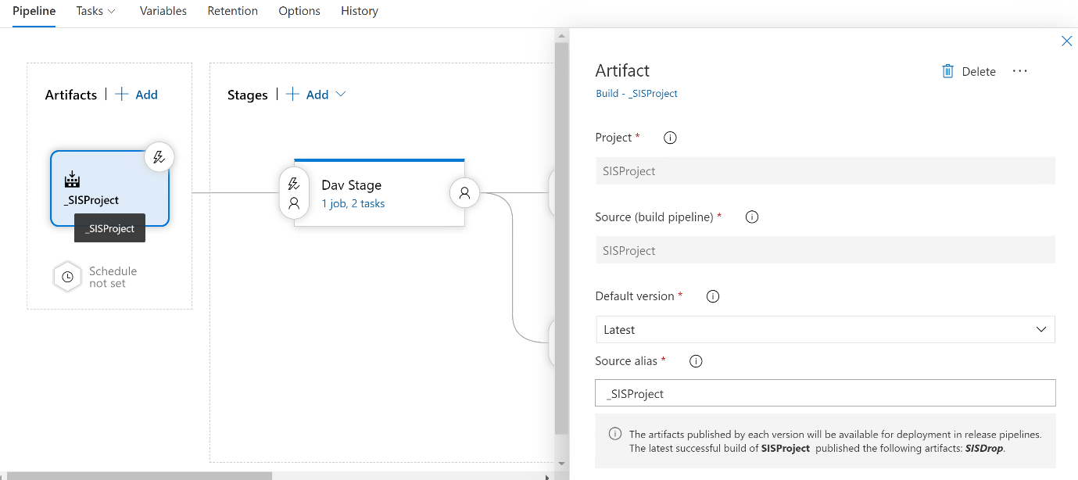

**Dave Stage:**

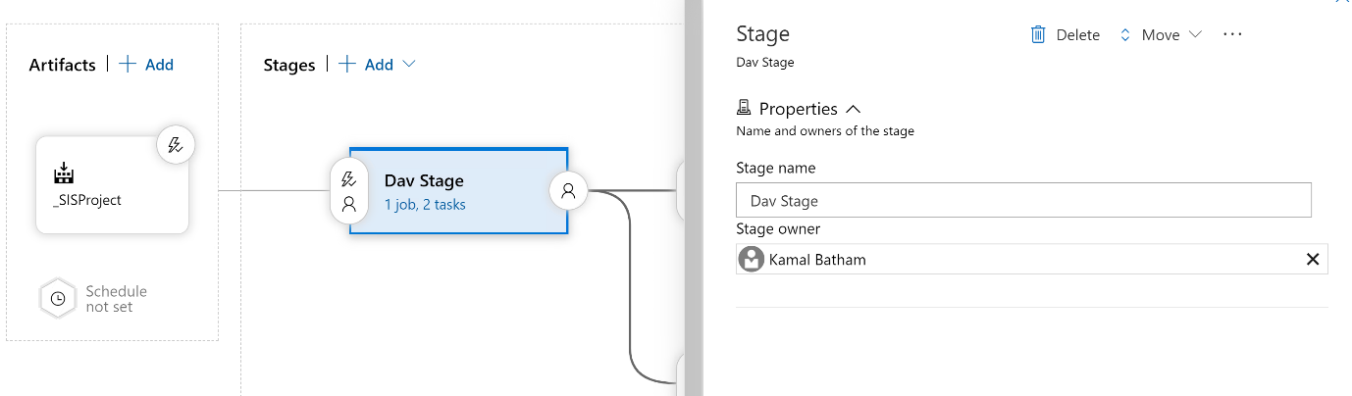

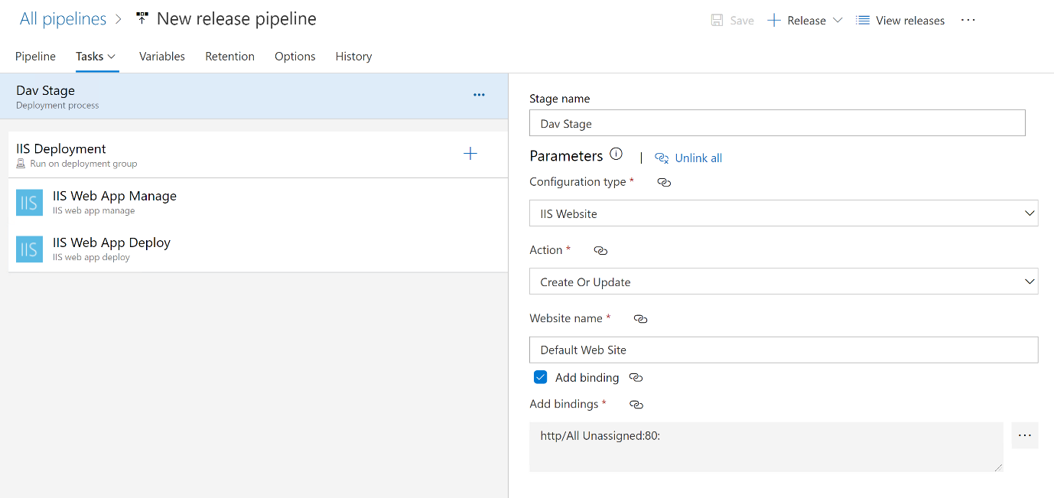

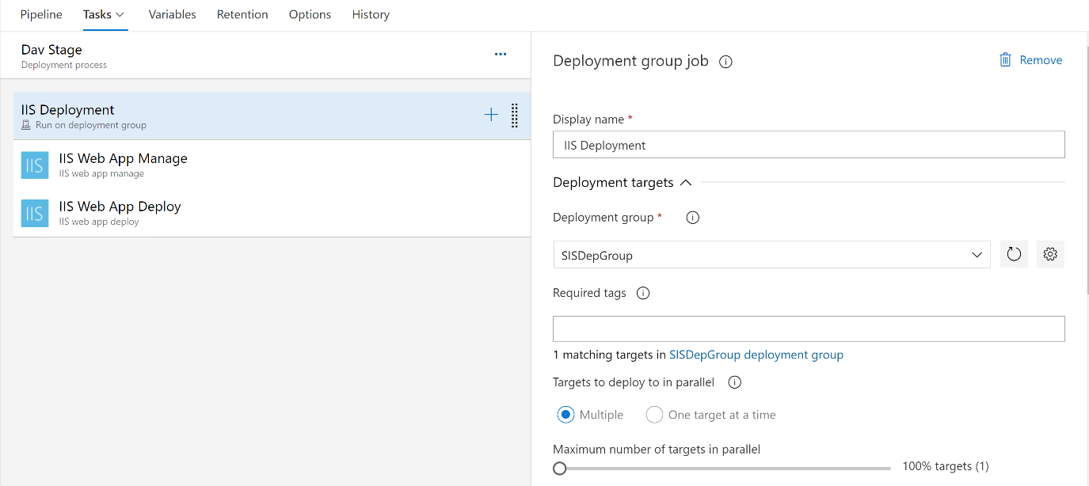

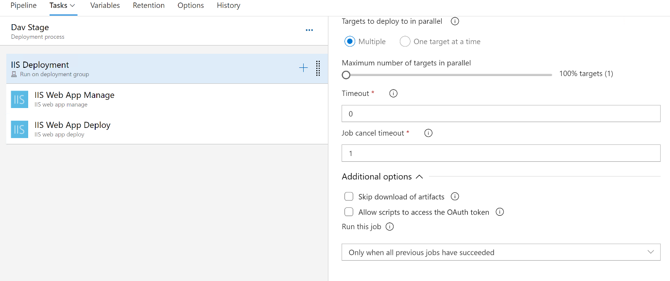

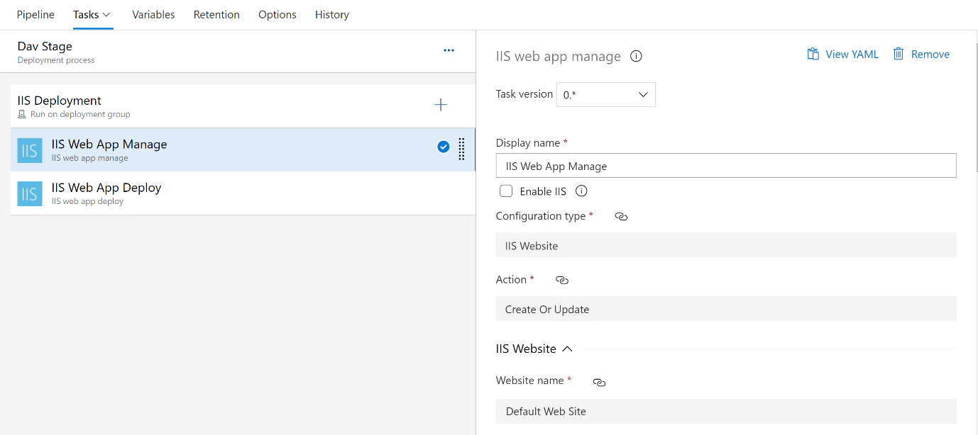

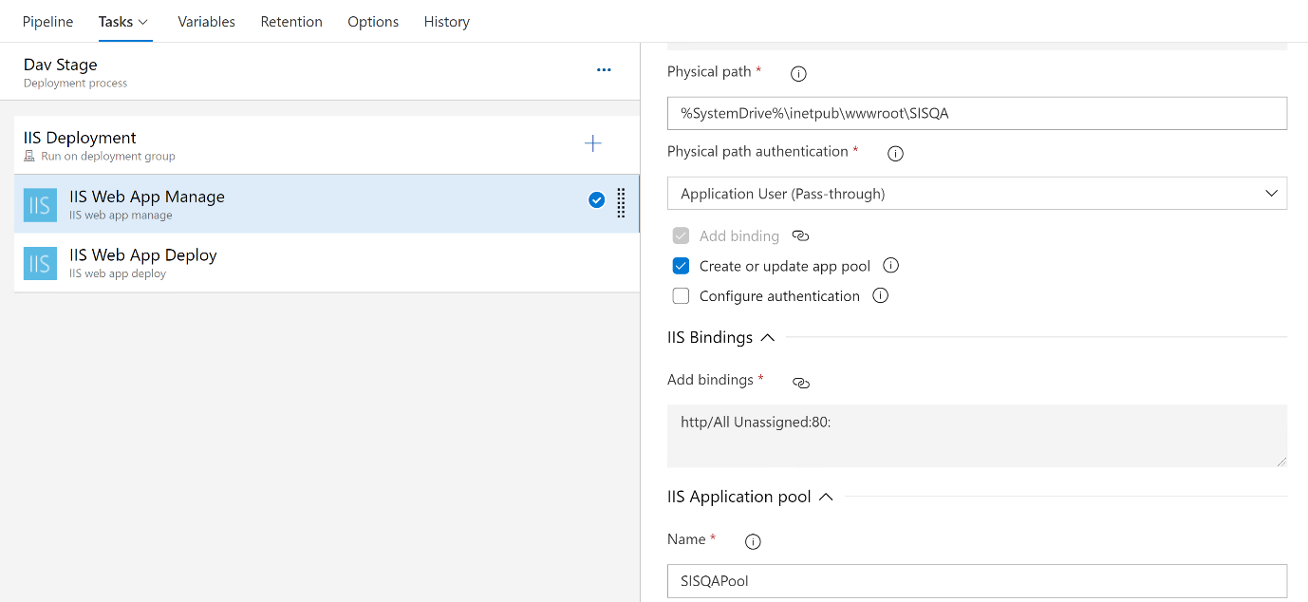

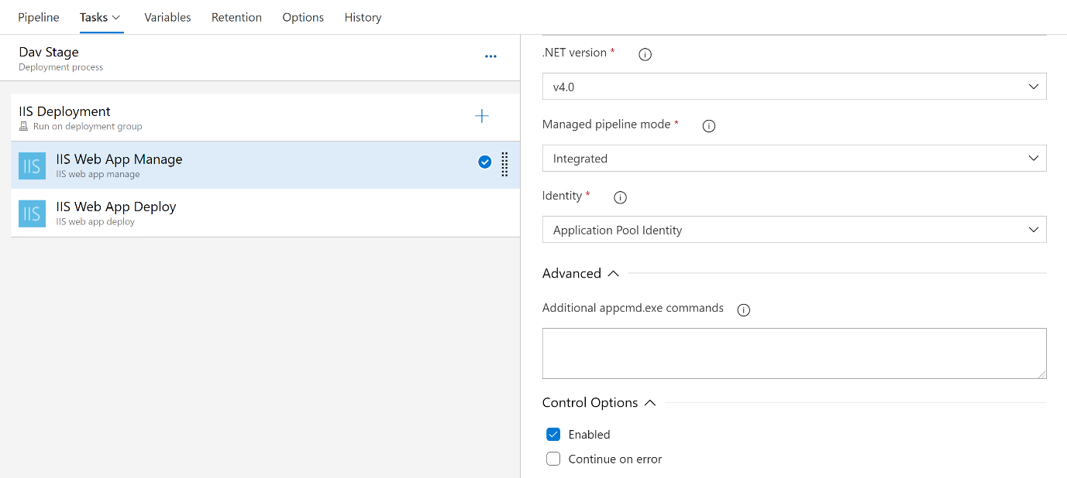

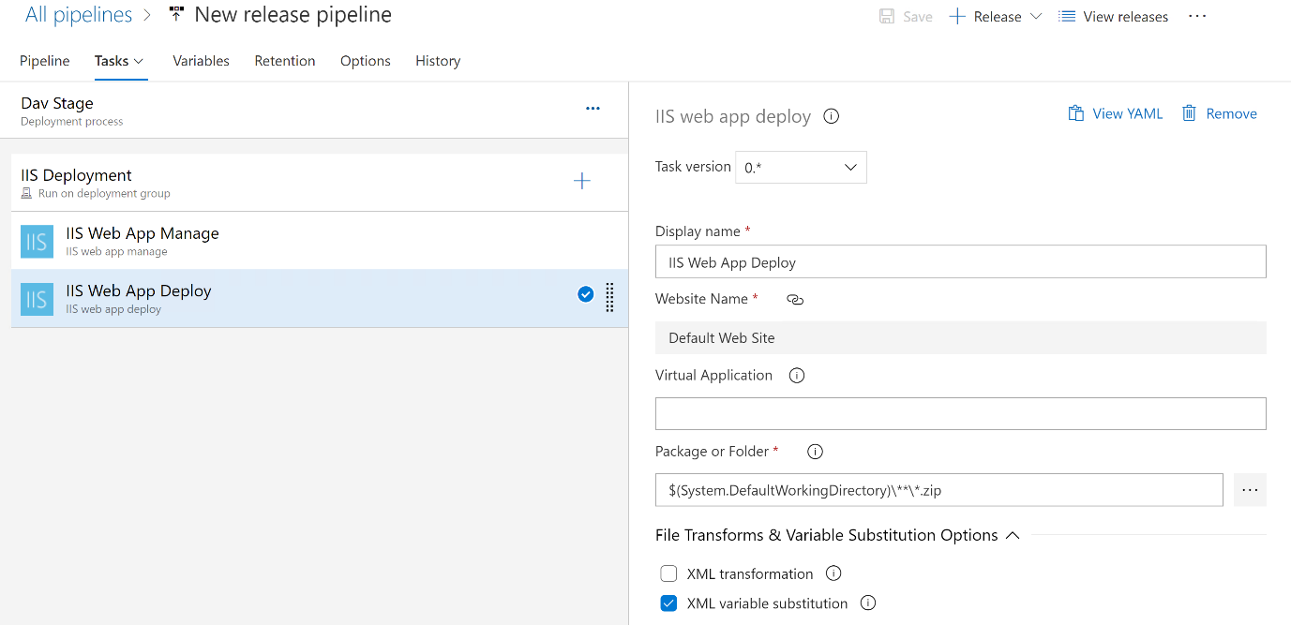

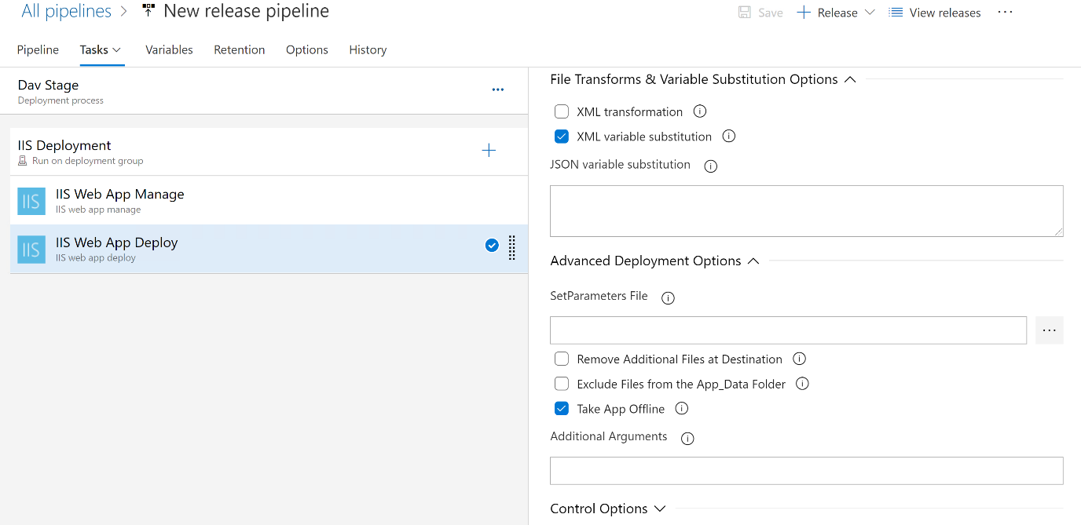

**Variables:**

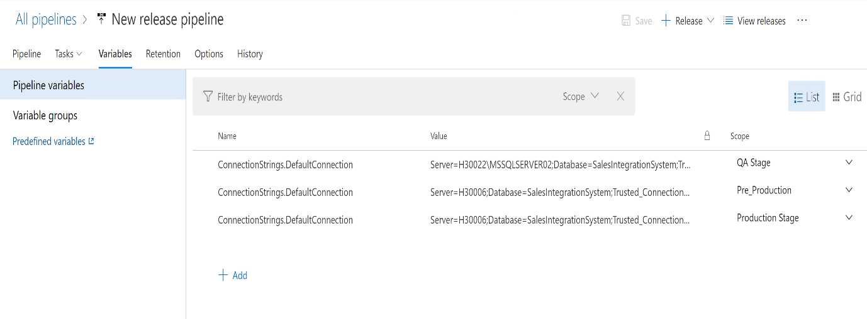

**--------------------------------------------------------------------------------------------------------------------------------------**

**QA Stage:**

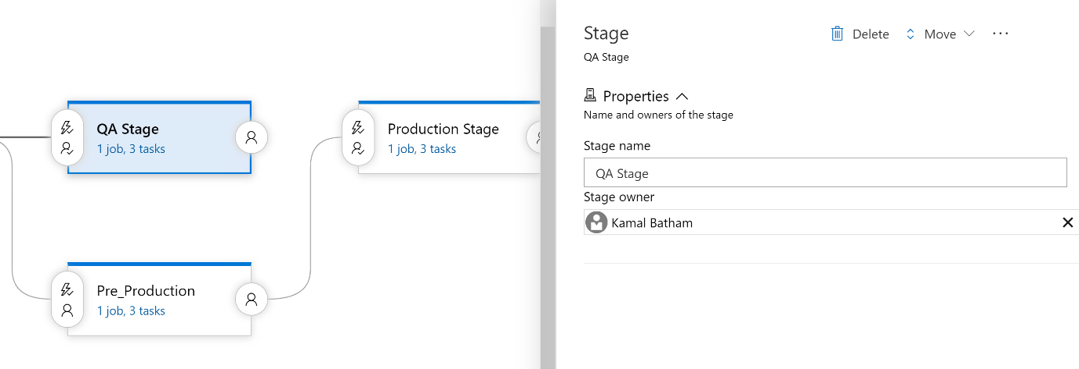

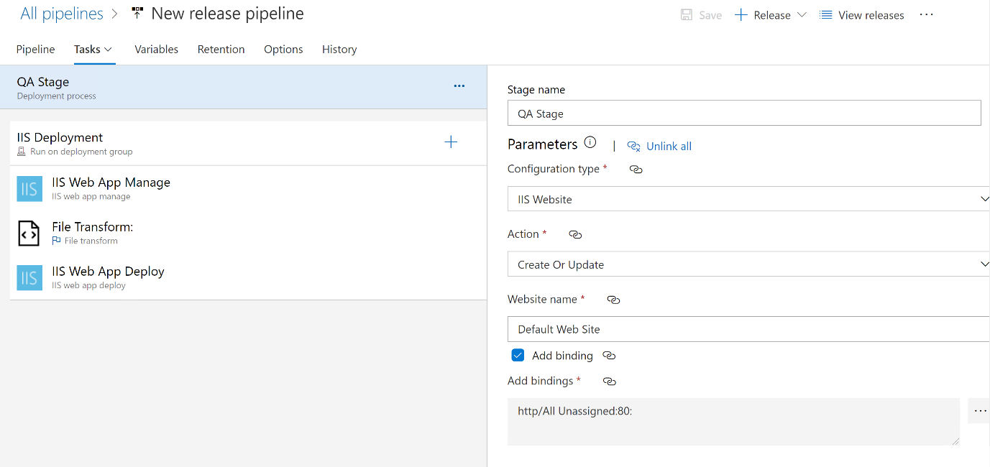

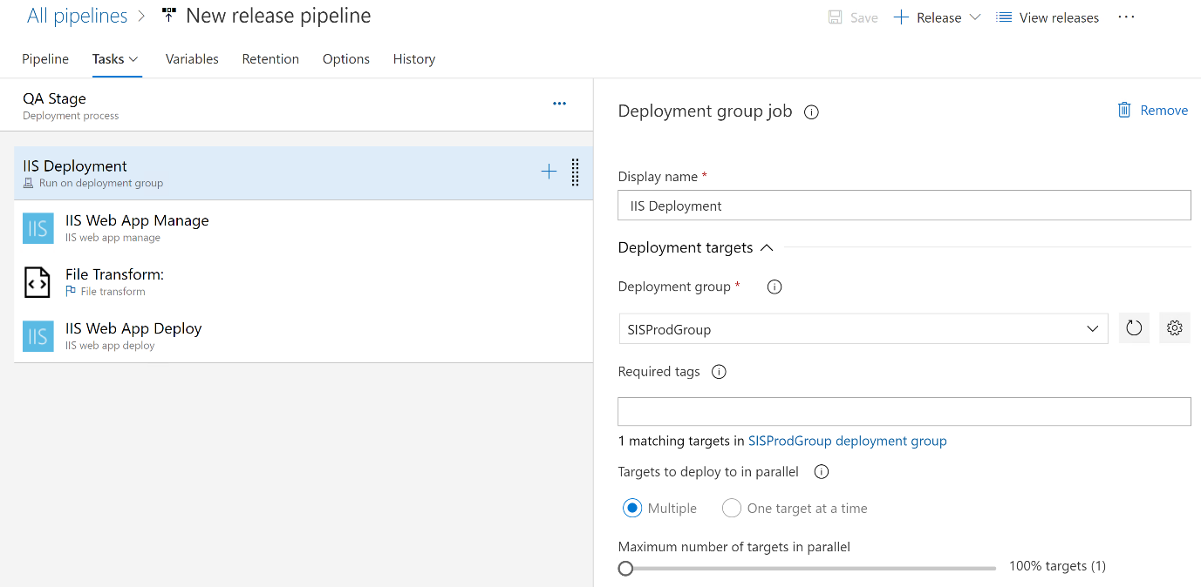

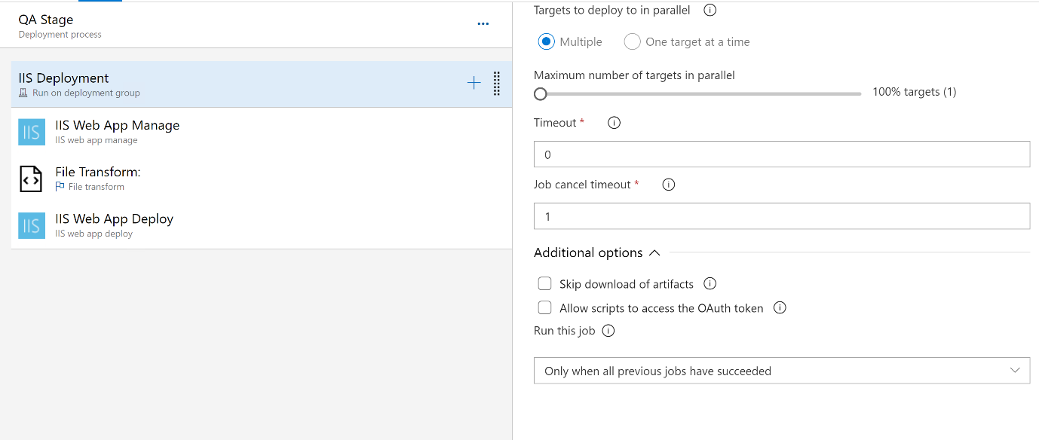

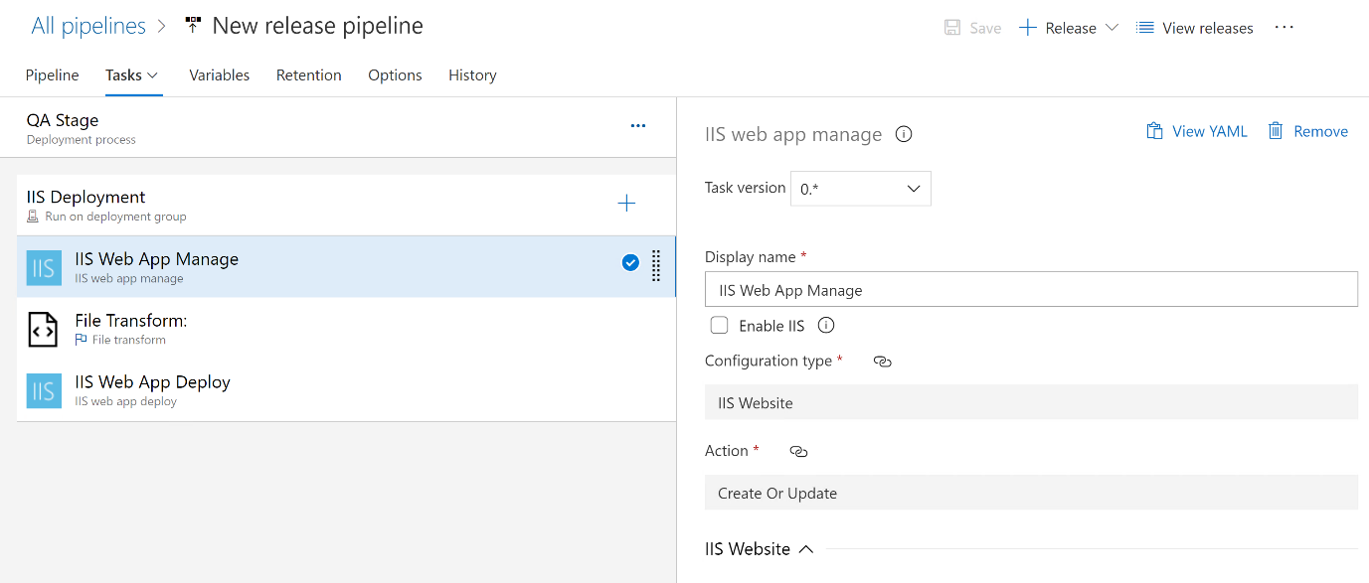

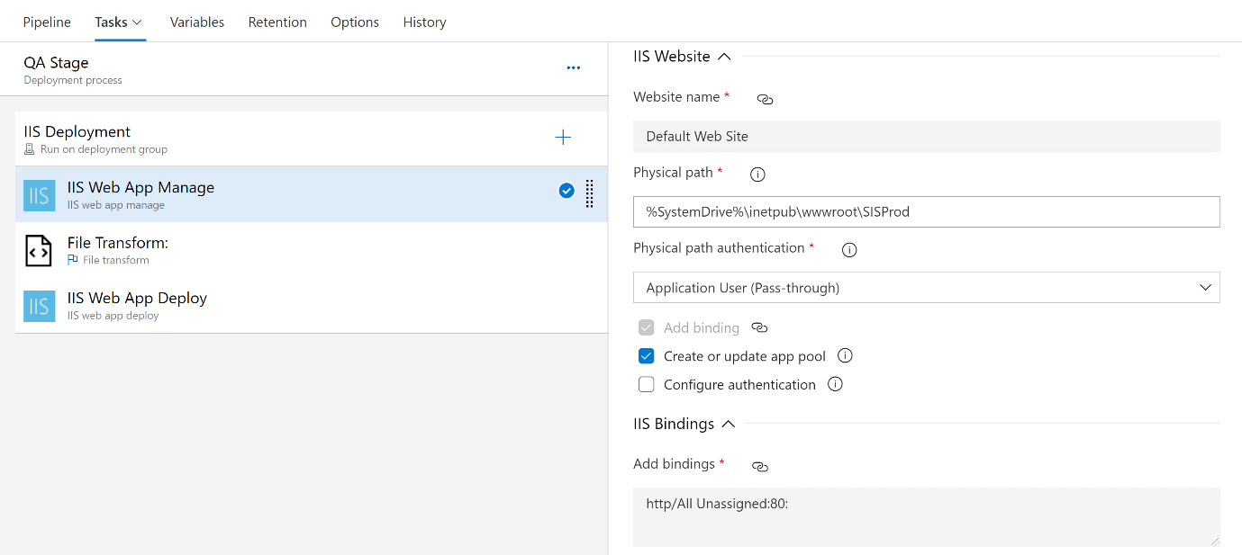

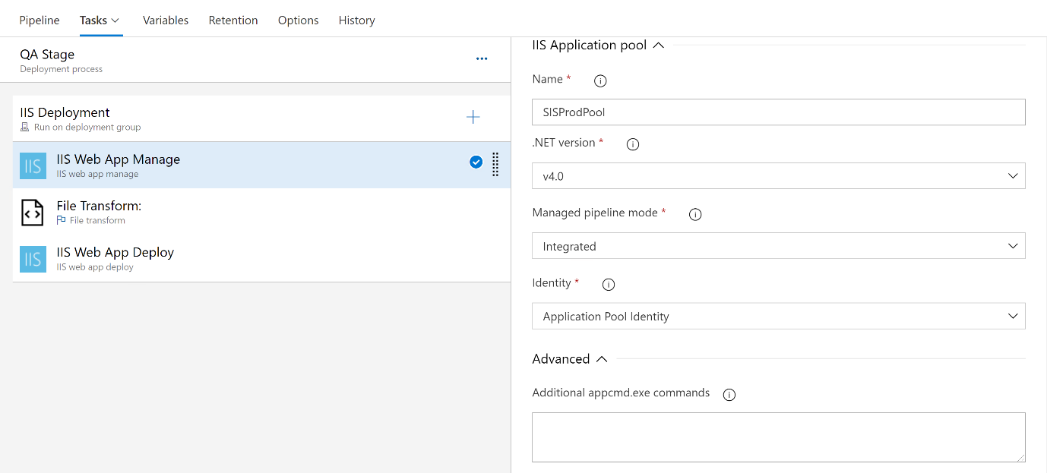

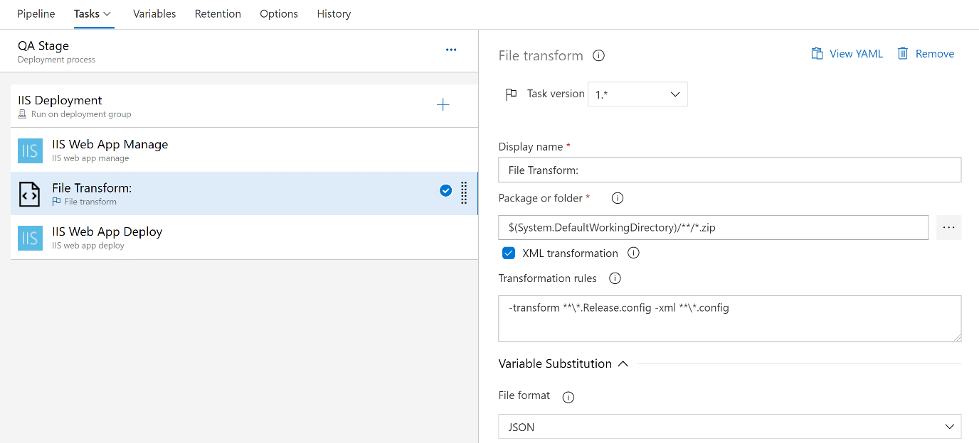

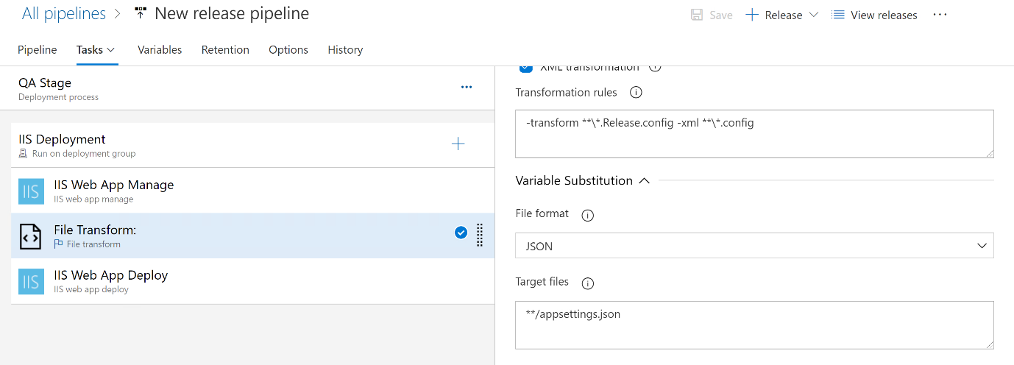

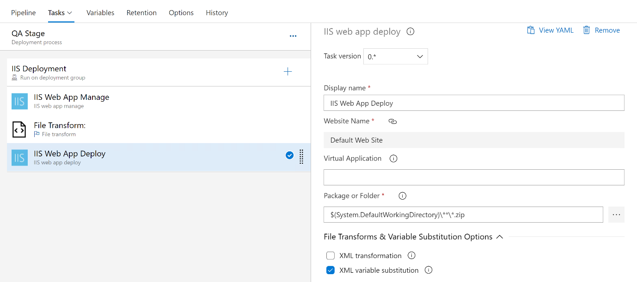

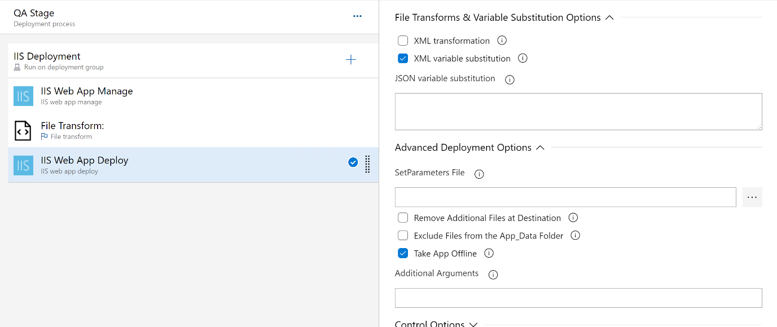

**------------------------------------------------------------------------**

**Production Stage:**

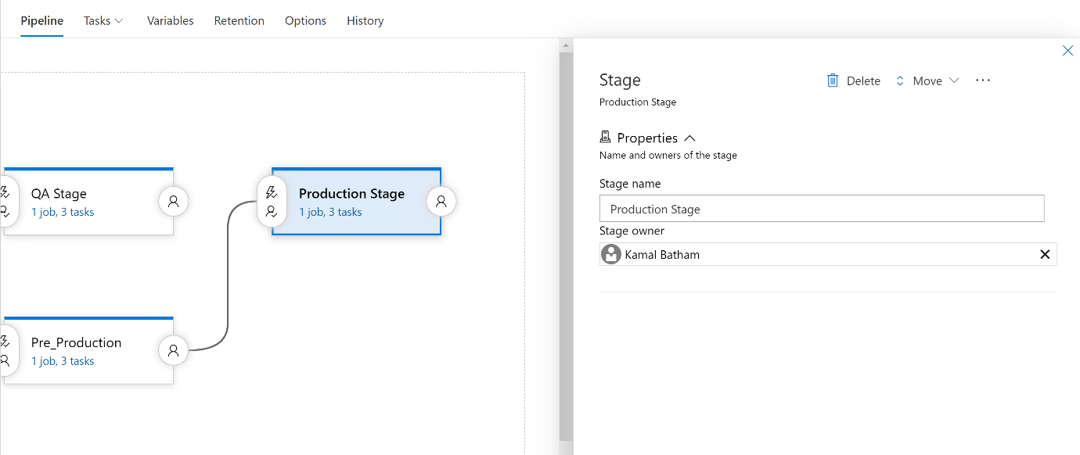

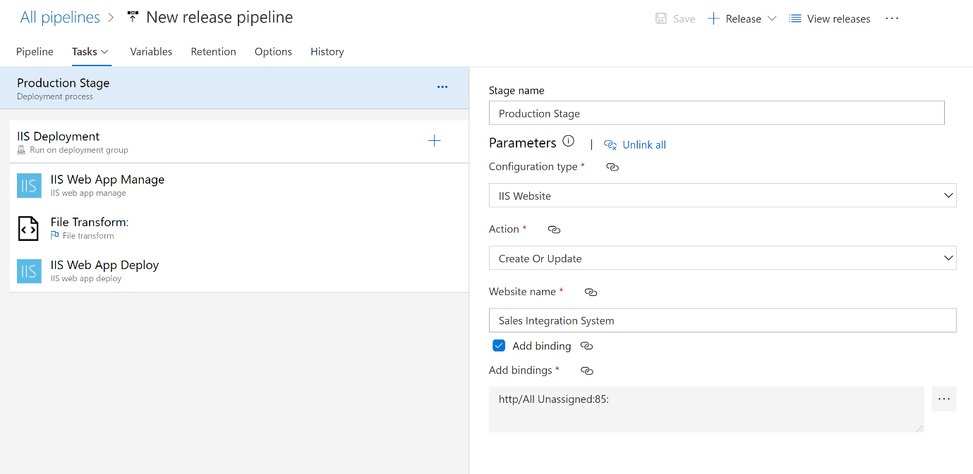

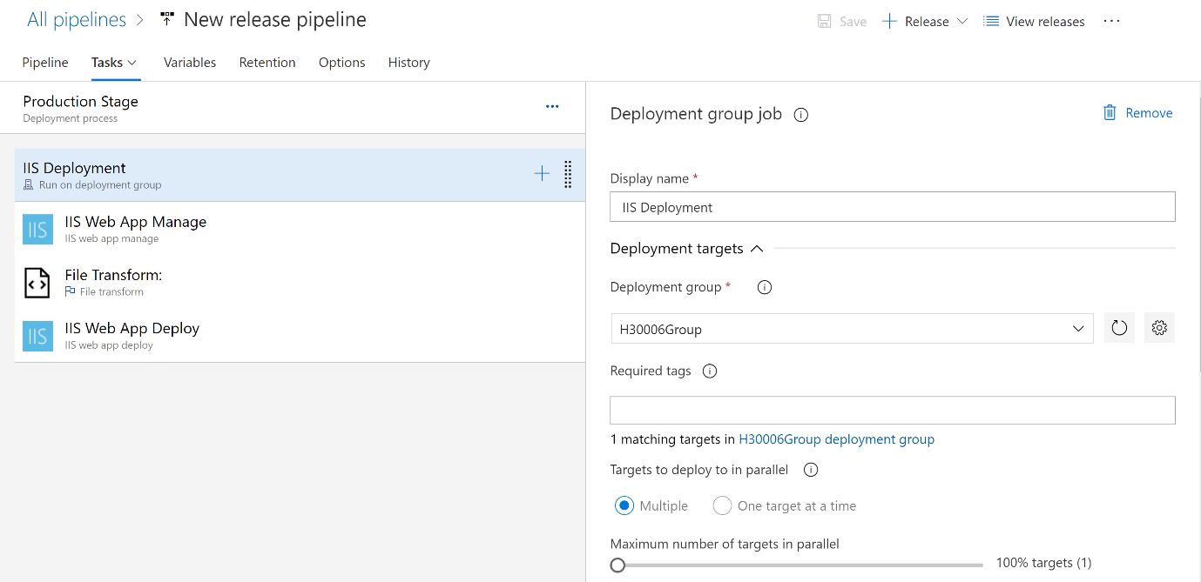

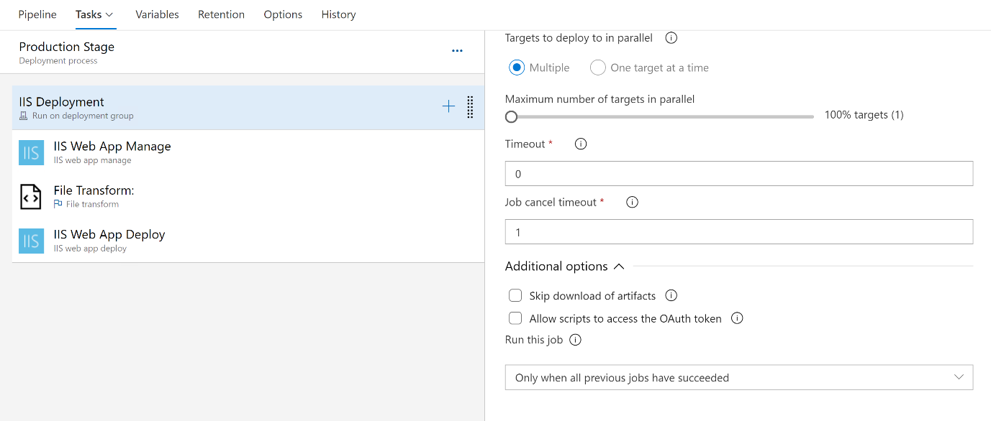

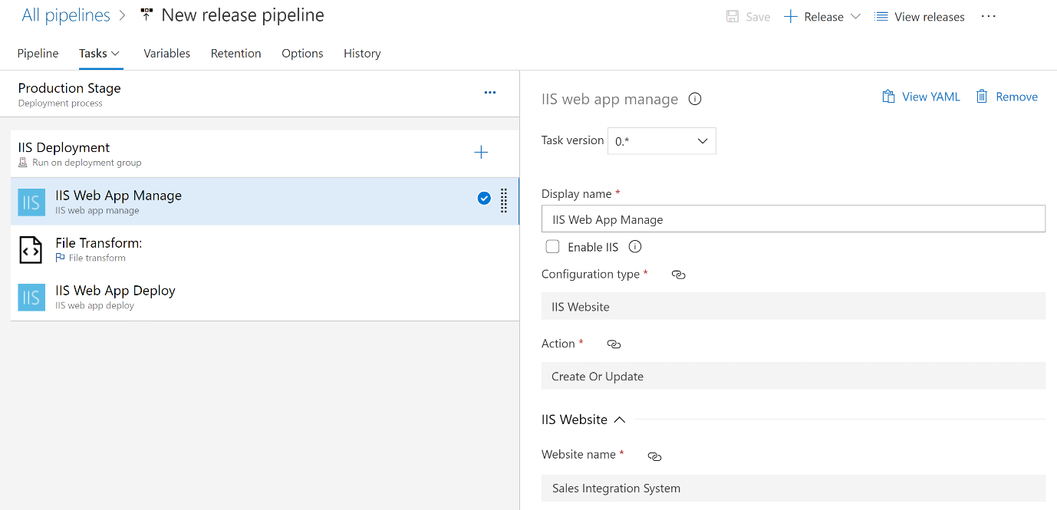

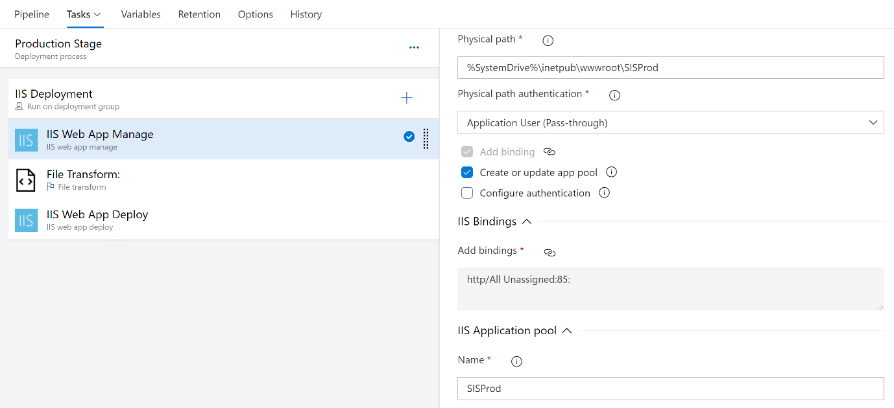

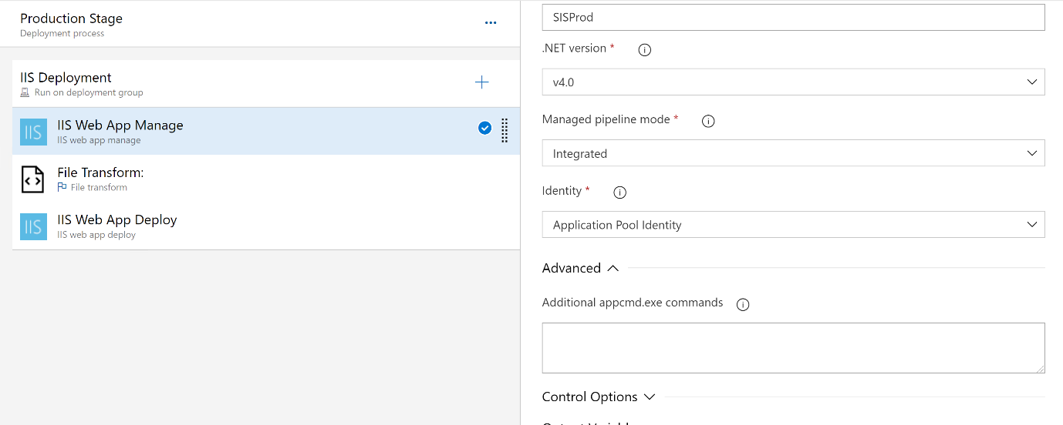

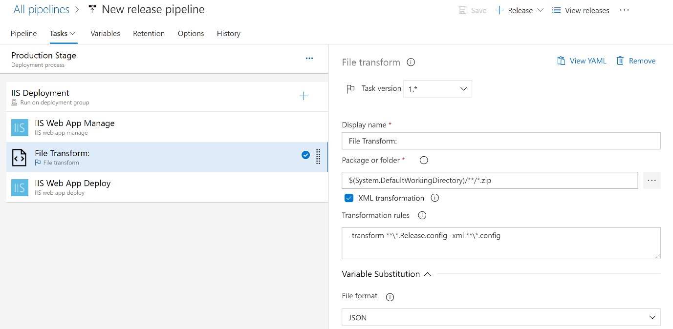

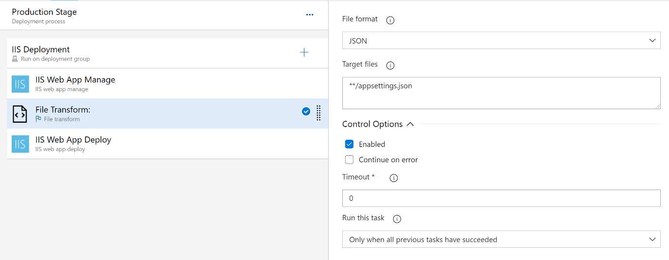

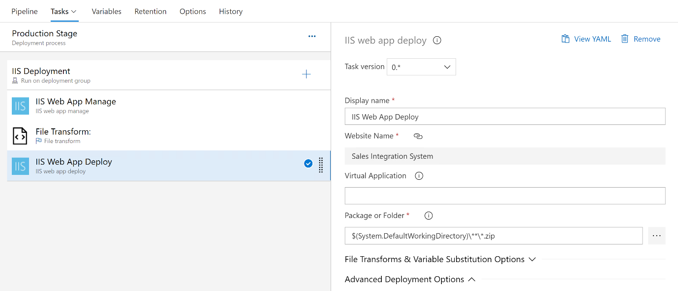

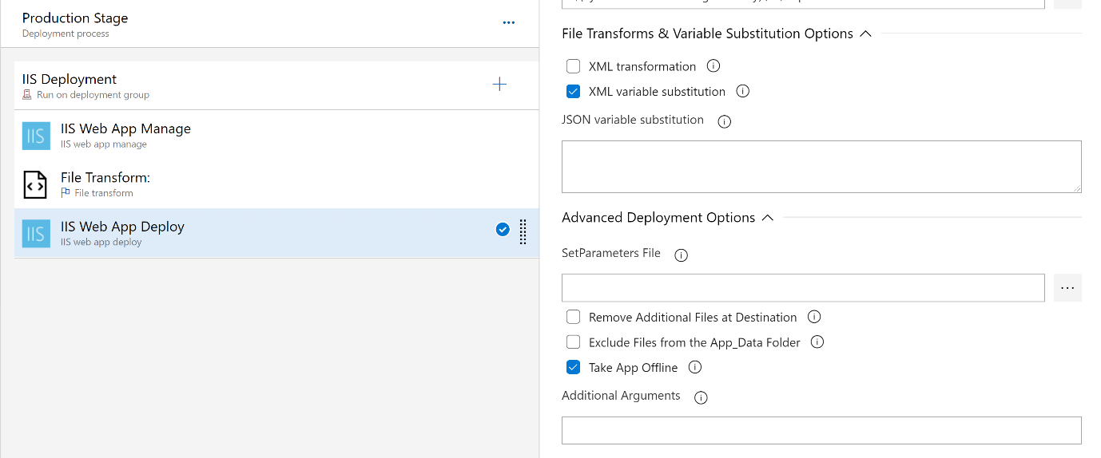

**-------------------------------------------------------------------------**

**Deployment Group**

